Toxic And Non-Toxic Plants To Dogs
TOXIC (Pg 1-22):
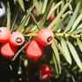 American Yew
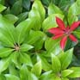 Andromeda Japonica
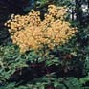 Angelica Tree
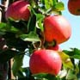 Apple
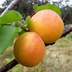 Apricot
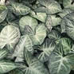 Arrow-Head Vine
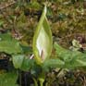 Arum
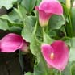 Arum Lily
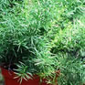 Asparagus Fern

Adam-and-Eve
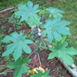 African Wonder Tree
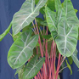 Alocasia
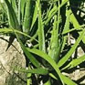 Aloe
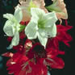 Amaryllis
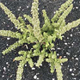 Ambrosia Mexicana
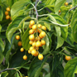 American Bittersweet
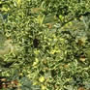 American Holly
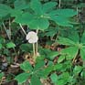 American Mandrake
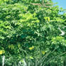 Australian Ivy Palm
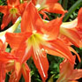 Barbados Lily
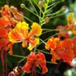 Barbados Pride
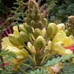 Barbados Pride 2
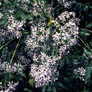 Bead Tree
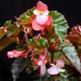 Begonia
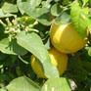 Bergamot Orange
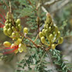 Bird of Paradise
Bird of Paradise 2
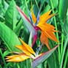 Bird of Paradise Flower

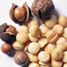 Australian Nut
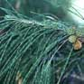 Australian Pine
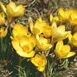 Autumn Crocus
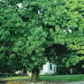 Avocado
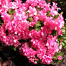 Azalea
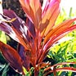 Baby Doll Ti Plant
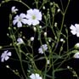 Baby’s Breath
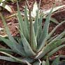 Barbados Aloe
Bird's Tongue Flower
Brazilwood
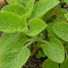 Bread and Butter Plant
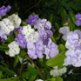 Brunfelsia
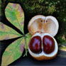 Buckeye
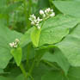 Buckwheat
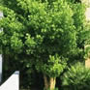 Buddhist Pine
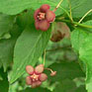 Burning Bush
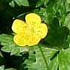 Buttercup
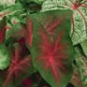 Caladium

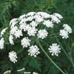 Bishop’s Weed
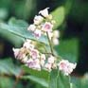 Bitter Root
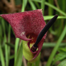 Black Calla
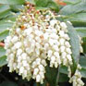 Black Laurel
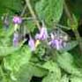 Black Nightshade
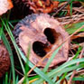 Black Walnut
Bobbins
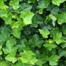 Branching Ivy
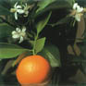 Calamondin Orange
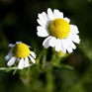 Chamomile
 Chandelier Plant
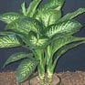 Charming Dieffenbachia
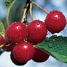 Cherry
Chinaberry Tree
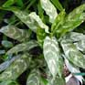 Chinese Evergreen
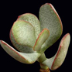 Chinese Jade
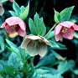 Christmas Rose
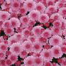 Chrysanthemum

California Ivy
Calla Lily
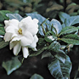 Cape Jasmine
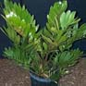 Cardboard Palm
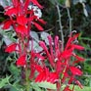 Cardinal Flower
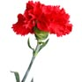 Carnation
Castor Bean Plant
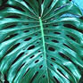 Ceriman
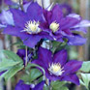 Clematis
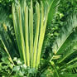 Coontie Palm
Cordatum
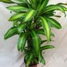 Corn Plant
Cornstalk Plant
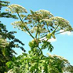 Cow parsnip
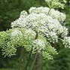 Cowbane
Cuckoo-pint
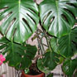 Cutleaf Philodendron
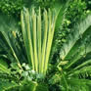 Cycads

Climbing Bittersweet
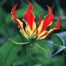 Climbing Lily
Climbing Nightshade
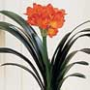 Clivia Lily
Coffee Tree
Coffee Tree 2
Coleus
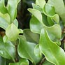 Common Privet
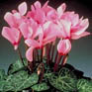 Cyclamen
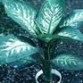 Dieffenbachia
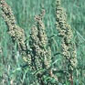 Dock
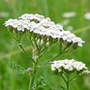 Dog Daisy
Dog Hobble
Dogbane Hemp
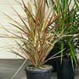 Dracaena
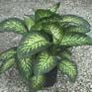 Dumbcane
Dwarf Poinciana
Easter Rose

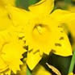 Daffodil
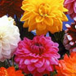 Dahlia
Daisy
Deadly Nightshade
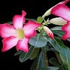 Desert Azalea
Desert Rose
Devil's Backbone
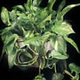 Devils Ivy
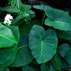 Elephant Ears
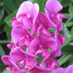 Everlasting Pea
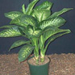 Exotica
False Bittersweet
False Queen Anne’s Lace
Feather Geranium
Fern Palm
Fetter Bush
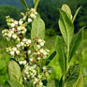 Fetterbush
Fiddle-Leaf

Elephant Ears
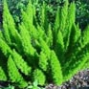 Emerald Feather
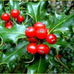 English Holly
English Ivy
English Yew
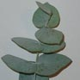 Eucalyptus
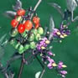 European Bittersweet
European Holly
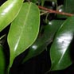 Fig
Franciscan Rain Tree
Garden Calla
Garden Chamomile
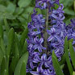 Garden Hyacinth
Gardenia
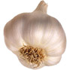 Garlic
Geranium
Geranium-Leaf Aralia
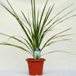 Giant Dracaena

Figwort
Fire Lily
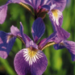 Flag
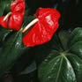 Flamingo Flower
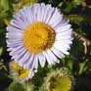 Fleabane
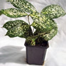 Florida Beauty
Florist's Calla
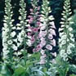 Foxglove
Giant Dumb Cane
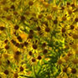 Golden Ragwort
Good Luck Plant
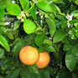 Grapefruit
Grass Palm
Greater Ammi
Green Gold Naphthysis
Ground Apple
Groundsel
Hahn's Self Branching English Ivy

Giant Hogweed
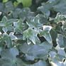 Glacier Ivy
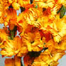 Gladiola
Gloriosa Lily
Gold Dieffenbachia
Gold Dust Dracaena
Golden Birds Nest
Golden Pothos
Hashish
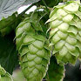 Hops
Horse Chestnut
Horsehead Philodendron
Horseweed
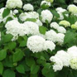 Hortensia
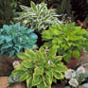 Hosta
House Pine
Hurricane Plant
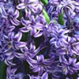 Hyacinth

Hawaiian Ti
Heartleaf Philodendron
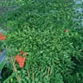 Heavenly Bamboo
Hellebore
Hercules' Club
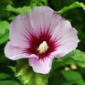 Hibiscus
Hills of Snow
Holly
Hydrangea
Iris
Ivy Arum
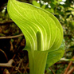 Jack-in-the-pulpit
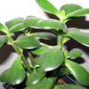 Jade Plant
Japanese Yew
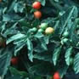 Jerusalem Cherry
Jerusalem Oak
Jonquil
Kaffir Lily

Impala Lily
Indian Apple
Indian Borage
Indian Hemp
Indian Hemp
Indian Pink
Indian Rubber Plant
Inkberry
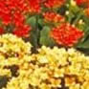 Kalanchoe
Laurel
Leatherflower
Leek
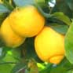 Lemon
Lenten Rose
Lily of the Palace
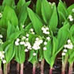 Lily of the Valley
Lily-of-the-Valley Bush
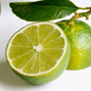 Lime

Kiss-me-quick
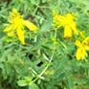 Klamath Weed
Kudu Lily
Lace Fern
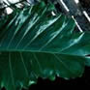 Lacy Tree Philodendron
Lady-of-the-night
Lantana
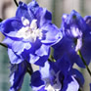 Larkspur
Lobelia
Marijuana
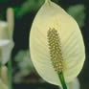 Mauna Loa Peace Lily
Mayapple
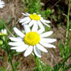 Mayweed
Meadow Saffron
Medicine Plant
Mexican Breadfruit
Milfoil
Milkweed

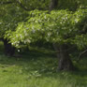 Locust
Lord-and-Ladies
Macadamia Nut
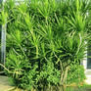 Madagascar Dragon Tree
Maidens Breath
Malanga
Maleberry
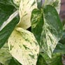 Marble Queen
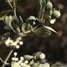 Mistletoe "American"
Mother-in-Law’s Tongue
Mum
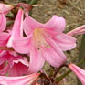 Naked Lady
Nandina
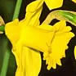 Narcissus
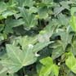 Needlepoint Ivy
Nephthytis
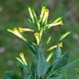 Nicotiana
Nightshade

Mock Azalea
Mole Bean Plant
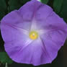 Morning Glory
Morning-Noon-and-Night
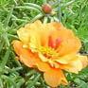 Moss Rose
Mother of Millions
Mother-in-Law
Mother-In-Law Plant
Norfolk Island Pine
Painter's Pallette
Palm Lily
Panda Plant
Paper White
Paraguayan Jasmine
Peace Lily
Peach
Peacock Flower
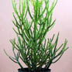 Pencil Cactus

Octopus Tree
Oilcloth Flower
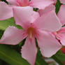 Oleander
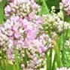 Onion
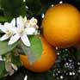 Orange
Oregon Holly
Ornamental Pepper
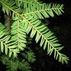 Pacific Yew
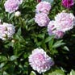 Peony
Plantain Lily
Plum
Plumosa Fern
Poinciana
Poinsettia
Poison Daisy
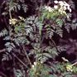 Poison Hemlock
Poison Parsnip
Portulaca

Perennial Pea
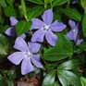 Periwinkle
Philodendron Pertusum
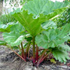 Pie Plant
Pieris
Pig Lily
Pigtail Plant
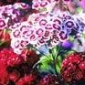 Pinks
Pothos
Ragwort
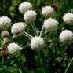 Ranger's Button
Red Emerald
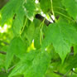 Red Maple
Red Princess
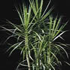 Red-Marginated Dracaena
Rhododendron
Rhubarb
Ribbon Plant

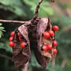 Prayer Bean
Precatory Bean
Pride-of-India
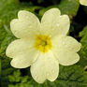 Primrose
Privet
Purslane
Queensland Nut
Racemose asparagus
Ridderstjerne
Saddle Leaf
Sago Palm
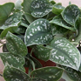 Satin Pothos
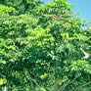 Schefflera
Seaside Daisy
Seven Bark
Shamrock Plant
Shatavari
Showy Daisy

Rock Moss
Roman Chamomile
Rose of China
Rose of Sharon
Rosebay
Running Myrtle
Sabi Star
Sacred Bamboo
Silver Dollar
Split Leaf Philodendron
Spotted Dumb Cane
Sprengeri Fern
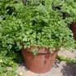 Spring Parsley
St. John’s Wort
Staggerbush
Starch Root
Starleaf
Stinking Chamomile

Silver Jade Plant
Skunk Cabbage
Snake Lilly
Snake Plant
Solomon’s Lily
Sowbread
Spanish Thyme
Spindle Tree
Straight-Margined Dracaena
Taro
Taro
Taro Vine
Texas Umbrella Tree
Ti-Plant
Tobacco
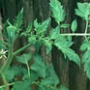 Tomato Plant
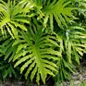 Tree Philodendron
Tree Tobacco

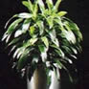 Striped Dracaena
Superb Lily
Swamp Maple
Sweet Pea
Sweet William
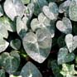 Sweetheart Ivy
Swiss Cheese Plant
Tail Flower
Tropic Snow
Virgin's Bower
Wahoo
Wake Robin
Warneckei Dracaena
Water Flag
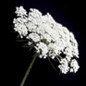 Water Hemlock
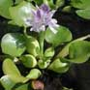 Water Hyacinth
Wax-Leaf
Weeping Fig

True Aloe
Trumpet Lily
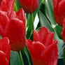 Tulip
Umbrella Leaf
Umbrella Tree
Variable Dieffenbachia
Variegated Philodendron
Vinca
Western Yew
Yarrow
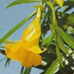 Yellow Oleander
Yesterday, Today, Tomorrow
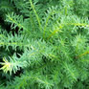 Yew
Yew Pine
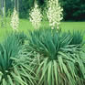 Yucca

White Heads
Wild Arum
Wild Calla
Wild Carnation
Wild Coffee
Winter Cherry
Winterberry
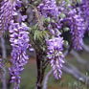 Wisteria

NON-TOXIC:
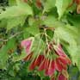 Amur Maple
Anthericum Comosum
Antirrhinum Multiflorum
Antirrhinum Multiflorum
Arabian Gentian
Areca Palm
Aregelia
Artillery Plant
Aspidium falcatum
Achira
Acorn Squash
African Daisy
African Violet
Algaroba
Aluminum Plant
Alumroot
Alyssum
American Rubber Plant
Aspidium falcatum 2
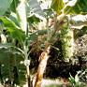 Banana
Banana Squash
Barberton Daisy
Beets
Begonia, Climbing
Begonia, Trailing
Belmore Sentry Palm
Big Shagbark Hickory
Big Shellbark Hickory

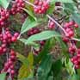 Autumn Olive
Baby Rubber Plant
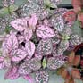 Baby’s Tears
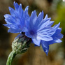 Bachelors Buttons
Ball Fern
Bamboo
Bamboo Palm
Bamboo Vine
Bitter Pecan
Blue Daisy 2
Blue Echeveria
Blue Eyed Daisy
Blue-dicks
Blue-dicks 2
Blue-dicks 3
Bluebottle
Blunt Leaf Peperomia
Blushing Bromeliad

Bitternut
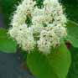 Black Haw
Black Hawthorn
Blaspheme Vine
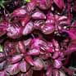 Bloodleaf
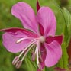 Blooming Sally
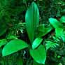 Blue Bead
Blue Daisy
Bold Sword Fern
Broom Hickory
Bullbrier
Bur Gourd
Burro's Tail
Buttercup Squash
Butterfly Ginger
Butterfly Iris
Butterfly Squash
Buzzy Lizzie

Boston Fern
Bottle Palm
Bottle Palm 2
Bottlebrush
Brazillian Orchid
Bride's Bonnet
Bristly Greenbrier
Brodiaea Pulchella
Caeroba
Calochortus nuttalli 2
Camellia
Canada Hemlock
Canary Date Palm
Candle Plant
Candycorn Plant
Cane Palm
Canna Lily
Canterbury-bell

Calathea Lancifolia
Calathea Lancifolia 2
Calathea Lancifolia 3
California Pitcher Plant
Callistemon Brachyandrus
Callistemon citrinus
Callistemon viminalis
Calochortus nuttalli
Cape Marigold
Casaba Melon
Cast Iron Plant
Cat Brier
Cat Ear
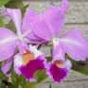 Cattleya Labiata
Celosia Globosa
Celosia Plumosa
Celosia Spicata
Chamaedorea

Cape Primrose
Carob
Caroba
Carolina Hemlock
Carrion Flower
Carrion Flower 2
Carrot Fern
Carrot Flower
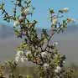 Chaparral
Chlorophytum
Chlorophytum Bechetii
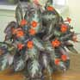 Chocolate Soldier
Christmas Cactus
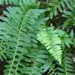 Christmas Dagger
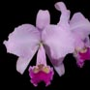 Christmas Orchid
Christmas Palm
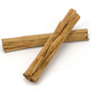 Cinnamon
Cinquefoil

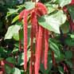 Chenille Plant
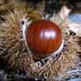 Chestnut
Chicken-Gizzard
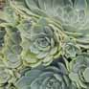 Chickens and Hens
Chin-lao-shu
China Aster
China Root
Chinese Plumbago
Cirrhopetalum
Common Garden Canna
Common Greenbrier
Common Snapdragon
Common Staghorn Fern
Confederate Jasmine
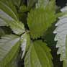 Coolwort
Copper Rose
Copperleaf
Coral Bells

Clearweed
Cliff Brake
Club Moss
Cocks Comb
Cocktail Orchid
Collinia Elegans
Common Camellia
Common Catbrier
Coreopsis
Crepe Myrtle
Crimson Bottlebush
Crimson Cup
Crisped Feather Fern
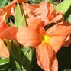 Crossandra
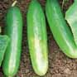 Cucumber
Cushion Moss
Cushon Aloe
Cyrtudeira

Cornflower
Crape Myrtle
Creeping Charlie
Creeping Gloxinia
Creeping Mahonia
Creeping Pilea
Creeping Rubus
Creeping Zinnia
Dainty Rabbits-Foot Fern
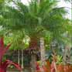 Dwarf Date Palm
Dwarf Feather Palm
Dwarf Palm
Dwarf Rose-Stripe Star
Dwarf Royal Palm
Dwarf Whitman Fern
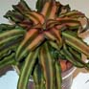 Earth Star
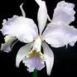 Easter Cattleya
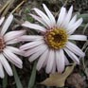 Easter Daisy

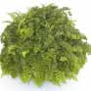 Dallas Fern
Dancing Doll Orchid
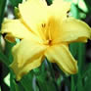 Day Lilies (many varieties)
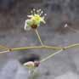 Desert Trumpet
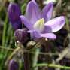 Dichelostemma
Dichorisandra Reginae
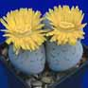 Dinteranthus Vanzylii
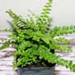 Duffii Fern
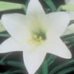 Easter Lily
Fairy Fountain
False Aralia
Fan Tufted Palm
Feather Palm
Fiery Reed Orchid
Fig Leaf Gourd
Figleaf Palm
Fingernail Plant
Fire Weed

Easter Lily Cactus
Easter Orchid
Eastern Star
Edible Banana
Elephant-Ear Begonia
Emerald Ripple Peperomia
English Hawthorn
Episcia
Fish Tail Fern
Freckle Face
Friendship Plant
Garden Marigold
Garden Snapdragon
Gerber Daisy
German Violet
Gherkins
Ghost Leafless Orchid
Ghost Plant

Flame African Violet
Flame of the Woods
Flamingo Plant
Florida Butterfly Orchid
Florida Butterfly Orchid
Fluffy Ruffles
Forster Sentry Palm
Fortunes Palm
Giant Aster
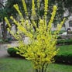 Golden Bells
Golden Butterfly Palm
Golden Lace Orchid
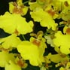 Golden Shower Orchid
Good Luck Palm
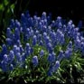 Grape Hyacinth
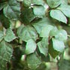 Grape Ivy
Great Willow Herb
Green Ripple Peperomia

Giant Holly Fern
Giant Touch-Me-Not
Giant White Inch Plant
Gibasis Geniculata
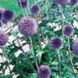 Globe Thistle
Gloxinia
Gold Bloom
Gold-Fish Plant
Greenbrier
Hen and Chickens Fern
Hens and Chickens
Hindu Rope Plant
Holligold
Holly Fern
Hollyhock
Honey Locust
Honey Plant
Honeydew Melon
Honeysuckle Fuchsia
Hookera pulchella
Hubbard Squash
Hypocyrta
Ice Plant

Hagbrier
Hardy Baby Tears
Hardy Gloxinia
Hare Fern
Haworthia
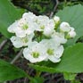 Haws
Haws Apple
Hawthorn
Hedgehog Gourd
Hellfetter
Hemlock Tree
Impatience Plant
Japanese Pittosporum
Japanese Show Lily
Jasmine
Jewel Orchid
Joseph's Coat
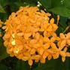 Jungle Geranium
Kaempferia
Kahali Ginger
Kenilworth Ivy

Irish Moss
Iron Cross Begonia
Iron Tree
Ivy Peperomia
Jackson Brier
Jacob's Ladder
Japanese Aralia
Japanese Holly Fern
Japanese Moss
Kentia Palm
Ladies Ear Drops
Lady Lou
Lady Palm
Lady Slipper
Lagerstroemia Indica
Lance Pleomele
Laurel-Leaved Greenbrier
Leather Peperomia
Leopard Lily

Kenya Violet
Kharoub
King and Queen Fern
King Nut
King of the Forest
Kuang-yen-pa-hsieh
Lace Flower Vine
Lace Orchid
Leopard Orchid
Living Stones
Locust Pods
Madagascar Jasmine
Magnolia Bush
Mahonia
Malabar Gourd
Malaysian Dracaema
Manila Palm
Mapleleaf Begonia
Maranta

Lesser Snapdragon
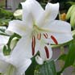 Lily
Lily of the Valley Orchid
Linden
Lipstick Plant
Little Fantasy Peperomia
Little Zebra Plant
Living Rock Cactus
Marbled Fingernail
Mexican Rosettes
Mexican Snowballs
Miniature Date Palm
Miniature Fish Tail
Miniature Maranta
Miniature Marble Plant
Mistletoe Cactus
Mockernut Hickory
Mosaic Plant

Mariposa Lily
Maroon
Maroon Chenille Plant
Mary-Bud
Measles Plant
Metallic Leaf Begonia
Metallic Peperomia
Mexican Firecracker
Mosaic Vase
Mountain Camellia
Mountain Grape
Mulberry Bush Greenbrier
Mulberry Tree
Musa Paradisiaca
Muscari Armeniacum
Muskmelon
Nasturtium
Natal Plum

Moss Agate
Moss Campion
Moss Fern
Moss Phlox
Mossy Campion
Mother Fern
Mother of Pearl
Mother Spleenwort
Neanthe Bella Palm
Oregon Grape
Ossifragi Vase
Paddys Wig
Painted Lady
Pampas Grass
Panamiga
Pansy Orchid
Paradise Palm
Parlor Palm

Nematanthus spp.
Neoregelia
Nerve Plant
Night Blooming Cereus
Old Man Cactus
Old World Orchid
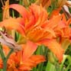 Orange Day Lily
Orange Star
Parsley Fern
Peperomia Rotundifolia
Peperomia Sandersii
Pepper Face
Persian Violet
Petunia
Pheasant Plant
Piggy Back Plant
Pignut Hickory
Pilea Microphylla

Patient Lucy
Patient Plant
Peace Begonia
Peacock Plant
Pearl Plant
Pearly Dots
Peperomia Hederifolia
Peperomia Peltfolia
Pilea Mucosa
Platinum Peperomia
Platycerium Alicicorne
Plumbago Larpentiae
Plush Plant
Poison Ivy
Poison Oak
Poison Sumac
Polka Dot Plant
Polystichum Falcatum

Pincushion Flower
Pink Brocade
Pink Pearl
Pink Splash
Pink Starlite
Pirliteiro
Pitaya
Plantanus Occidentalis
Pony Tail
Purple Baby Tears
Purple Passion Vine
Purple Velvet Plant
Purple Waffle Plant
Queencup
Queens Spiderwort
Queensland Arrowroot
Rabbits Foot Fern
Rainbow Orchid

Porcelain Flower
Pot Marigold
Prairie Lily
Prairie Snowball
Prayer Plant
Prickly Bottlebrush
Prostrate Coleus
Pupleosier Willow
Red African Violet
Rex Begonia
Rhynchophorum
Ribbon Plant (Chlorophytum Comosum)
Roosevelt Fern
Rose
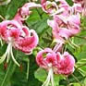 Rubrum Lily
Russian Olive
Saffron Spike Zebra
Saint Bernards Lily

Red Berried Greenbrier
Red Edge Peperomia
Red Hawthorne
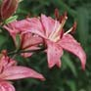 Red Lily
Red Palm Lily
Red Veined Prayer
Reed Palm
Resurrection Lily
Sand Lily
Shagbark Hickory
Shan Ku'ei-lai
Shellbark Hickory
Shrimp Cactus
Silver Bell
Silver Berry
Silver Heart
Silver Pink Vine
Silver Star

Sand Verbena
Satin Pellionia
Sawbrier
Scabious
Scarborough Lily
Scarlet Orchid
Scarlet Sage
Sego Lily
Silver Table Fern
Spider Plant
Star Jasmine
Star Lily
Star Plant
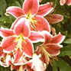 Stargazer Lily
Strawberry
Striped Blushing
Sugar Pods
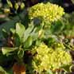 Sulfur Flower

Silver Tree Anamiga
Slender Deutzia
Small Fruited Hickory
Speckled Wood Lily
Spice Orchid
Spice Orchid
Spider Flower
Spider Ivy
Summer Hyacinth
Tall Mahonia
Tangerine Impatience
Teasel Gourd
Texas Sage
Thea Japonica
Thimble Cactus
Thorn Apple
Ti hu-ling
Tickseed

Sunflower
Swamp Sunflower
Swedish Ivy
Sweetheart Hoya
Sword Fern
Tahitian Bridal Veil
Tailed Orchid
Tall Feather Fern
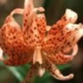 Tiger Lily
True Cantaloupe
Tu Fu-Ling
Tulip Poplar
Turban Squash
Turf Lily
Umbrella Plant
Urbinia Agavoides
Usambara Violet
Variegated Laurel

Tiger Orchid
Toad Spotted Cactus
Torch Lily
Tous-les-mois
Trailing Peperomia
Tree Cactus
Tree Gloxinia
Tropical Moss
Variegated Wandering Jew
Walking Anthericum
Wandering Jew
Washington Hawthorn
Water Hickory
Watermelon Begonia
Watermelon Peperomia
Watermelon Pilea
Wax Plant
Wax Rosette

Variegated Wax Plant
Velvet Plant
Venus Fly Trap
Verona Fern
Verona Lace Fern
Vining Peperomia
Violet Slipper Gloxinia
Waffle Plant
Weeping Bottlebrush
Wild Buckwheat
Wild Hyacinth
Wild Lantana
Wild Sasparilla
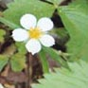 Wild Strawberry
Willow Herb
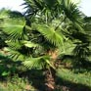 Windmill Palm
Winter Cattleya
Withered Snapdragon

Weeping Sargeant Hemlock
Weisdornbluten
West Indian Gherkin
Western Sword
White Edged Swedish Ivy
White Ginger
White Heart Hickory
Whitman Fern
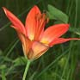 Wood Lily
Woolflower
Yellow Bloodleaf
Yellow Palm
Yellow-Flowered Gourd
Yerba Linda
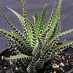 Zebra Haworthia
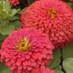 Zinnia
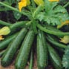 Zucchini Squash

